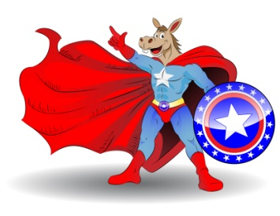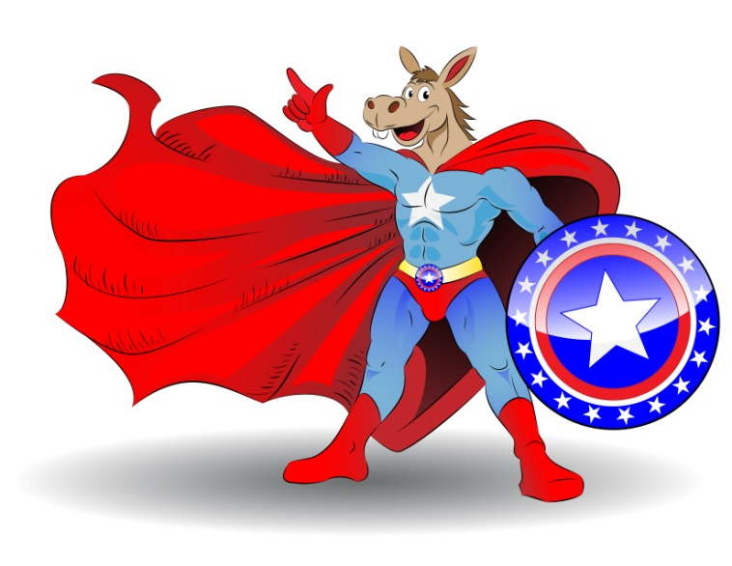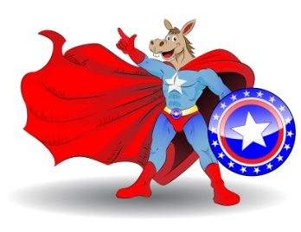

**TIME: 6:00 MONDAY, FEBUARY, 11**

**GAINESVILLE CITY DISTRICT# 4 @6:00**

**GAINESVILLE MAYORAL RACE @ 7:00**

**ACDBC DEBATES ARE**

**“FAIR AND BALANCED”**

**Alachua County Commission Races @7:00 -7:40**

**State Senate District # 7 @7:45 – 8:15**

**Congressional District 3 8:20 – 9:00**

**Alachua County Administration Building**

**12 S.E. First Street Gainesville Fl, 2ND fl**

**For Info Call Charles Goston (352) 231-0294,**

**Ermon Owens (352) 538-9690**

**Sheldon Packer (352) 870-8496**

**PAID POLITICAL ANNOUNCEMENT BY THE ALACHUA COUNTY DEMORCRATIC BLACK CAUCUS**

**ALACHUA COUNTY DEMOCRATIC BLACK CAUCUS**

**PRESENTS THE 2013 MUNICPAL**